Submiited by- Rithika
1.)Basic commands:
git init ( To initialize the repo)
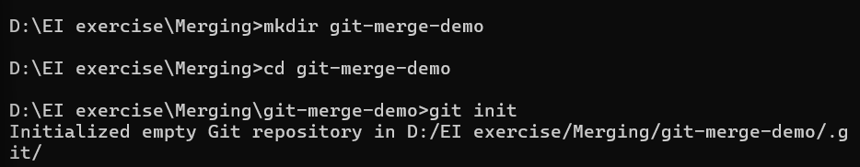
git config user.name “Name” (Sets commit author name)
git config user.email “email” (Sets commit author email)
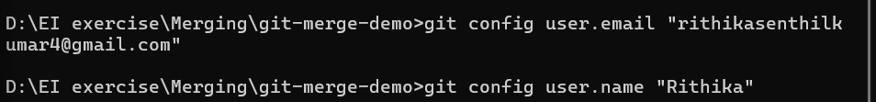
git config –list( To check configuration)
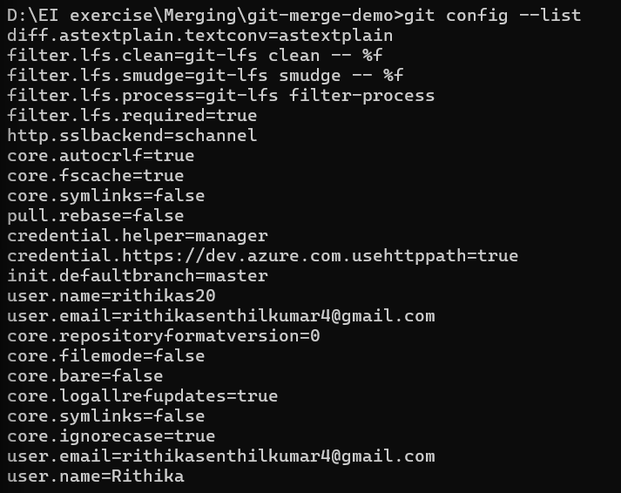

2.) Status: git status( before commit )
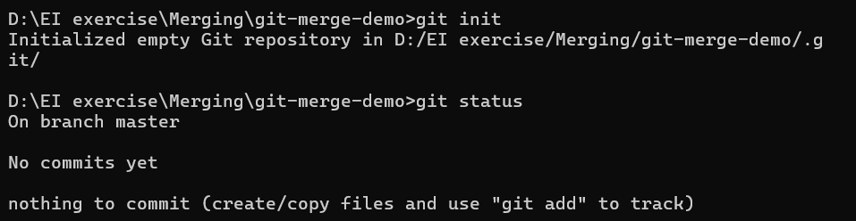
git status( Before adding files to index)
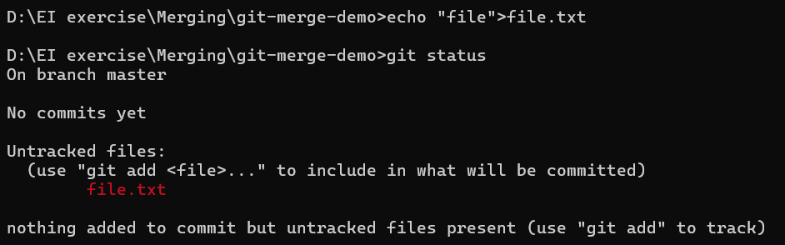
git status (After file added to staging area)
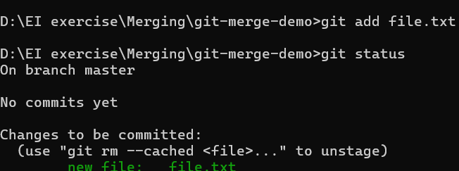
git status( After file been commited)
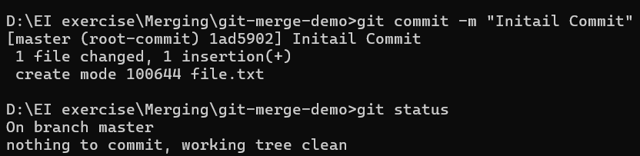

git status -M(Modified files)
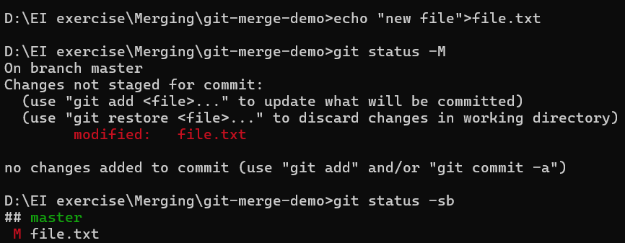
git status -sb(to view modified, untracked files )
3.)Commit
git commit -am “Message”(Commit without use of add)
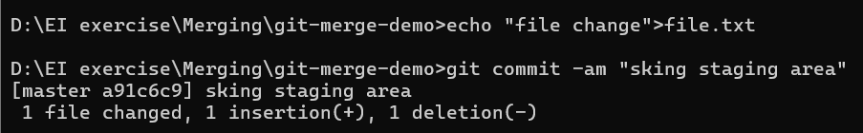
git commit –amend -m “Message”(Editting the prev commit message)
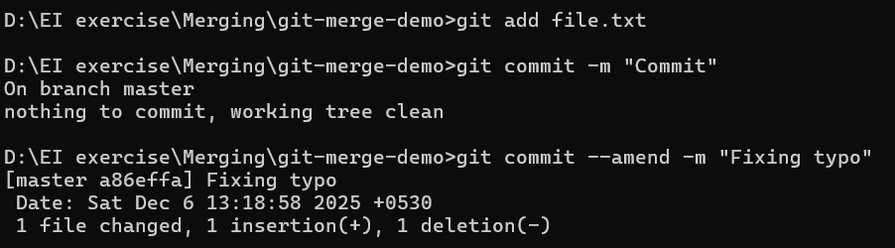

4.)Restore
git restore <filename> (file returns to previous commit version, changes lost)
git restore –staged <fname>(Your edits are NOT deleted — only unstaged.)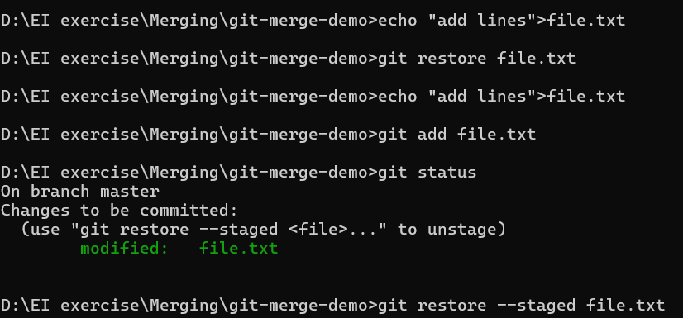
5.)git diff
git diff( line-level changes bt git trees)- To see what changes are not yet added
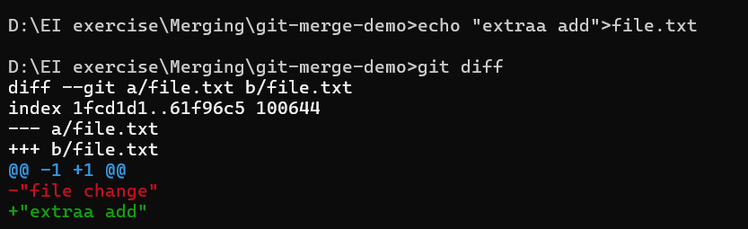

git diff –staged(difference between last commit and staging area.)
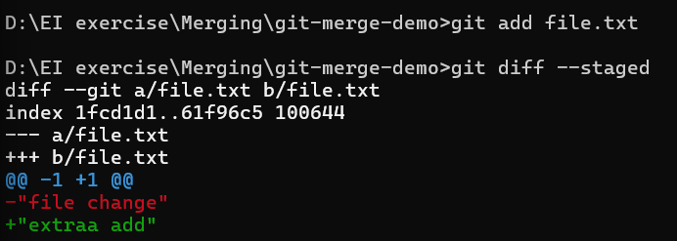
git diff HEAD( Compares working directory (including staged) with last commit.)
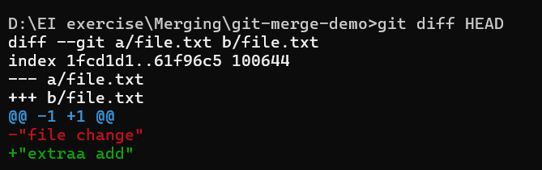
git diff branch1 branch2
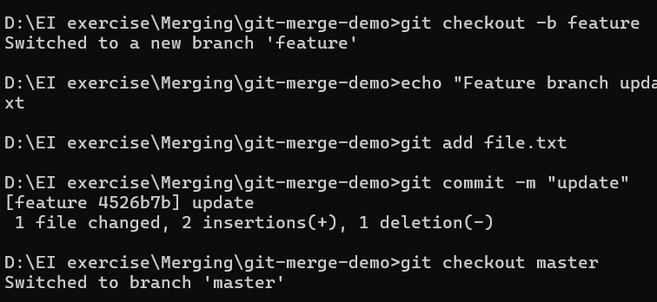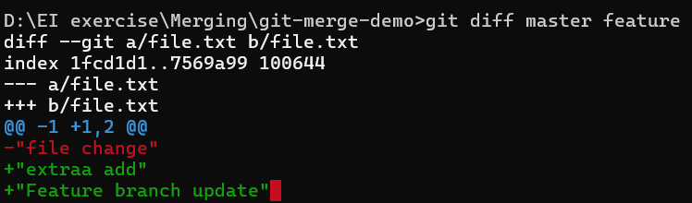
git diff <commit_hash1> <commit_hash2>
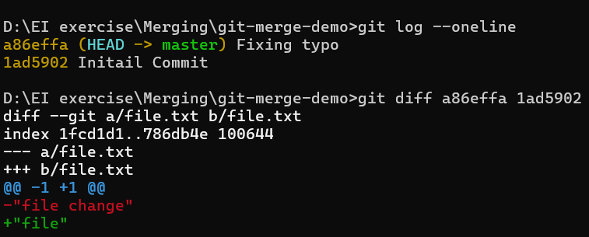
git diff branch1 branch2 --<fname>
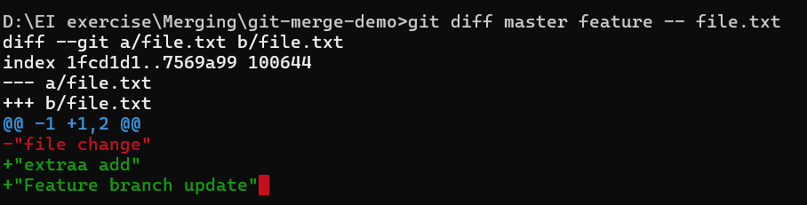
6.)git blame
git blame <fname>( who change each line change in the file)
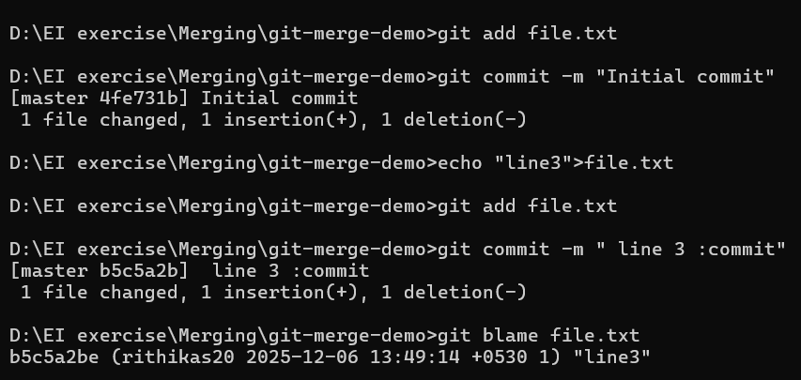

git blame -p <fname>( Blame with commit msg)
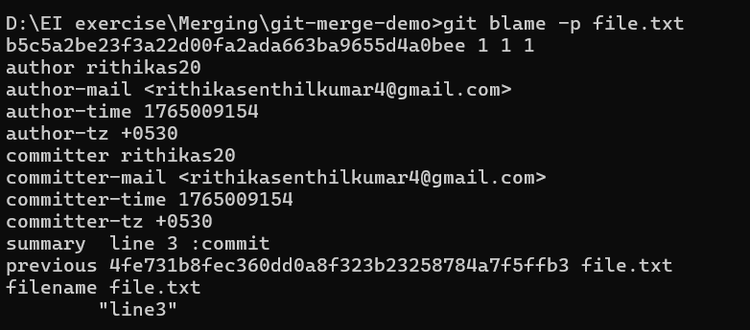
git blame <bname> --<fname>( Blame a file in another branch)
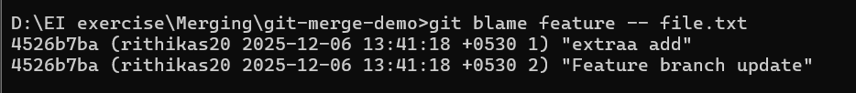
git blame -w <fname>(Ignore whitespace)
git blame -L start, end <fname>(show specific line range)
7.)git log
git log( commit history)
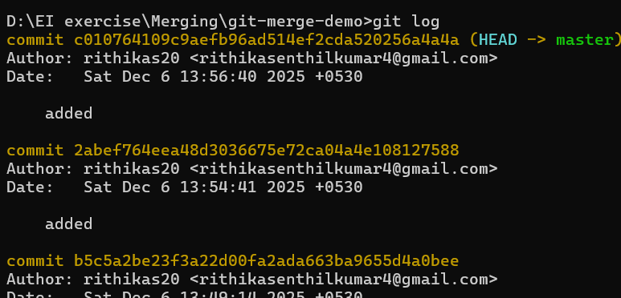
git log –oneline( compact view)
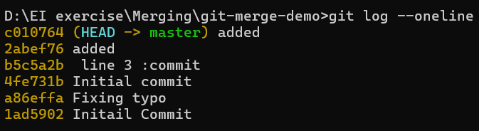
git log --oneline --graph --decorate –all(Graph view with branches)
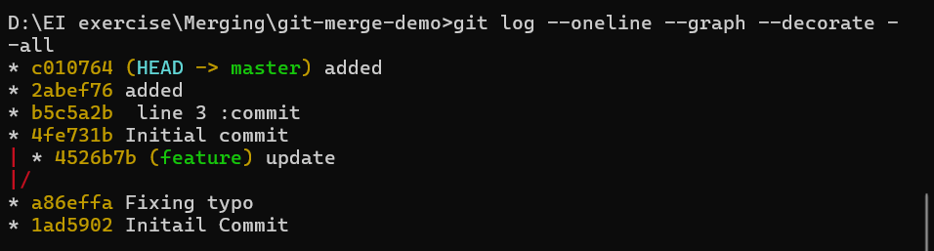
git log -p( show diff in each commit)
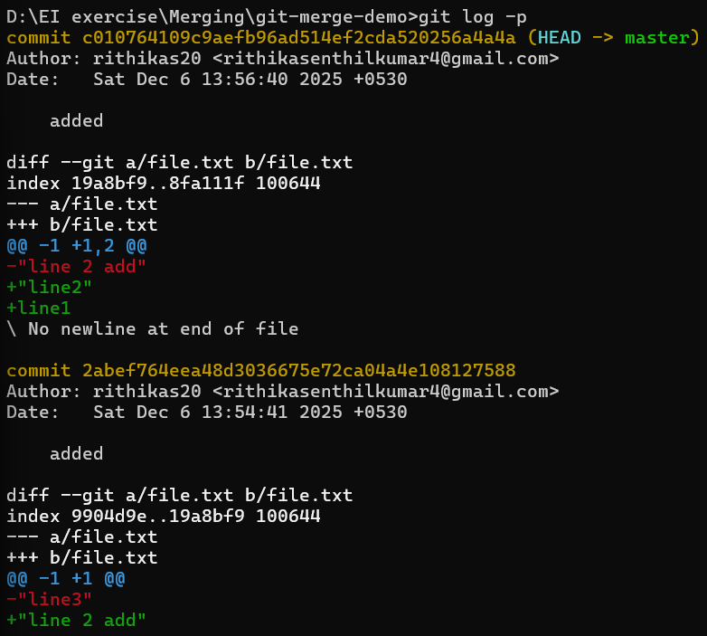

git log -number(show last n commits)
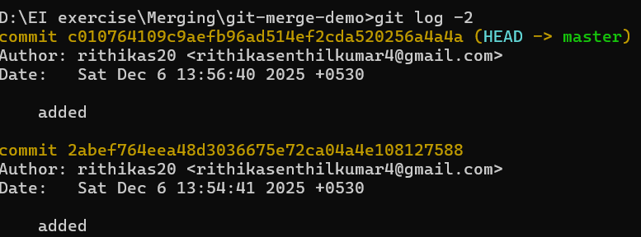
git log –grep=”Commit msg used”( show history by commit msg)
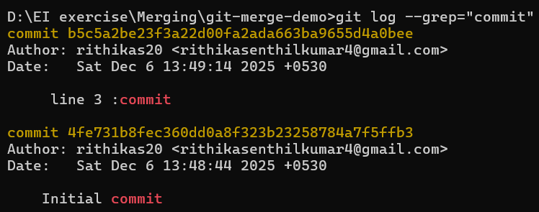
git log –merge( show only merge commit)
git log –no-merges(exclude merges)
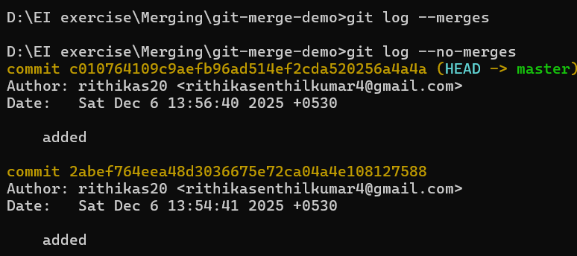

git log –stat
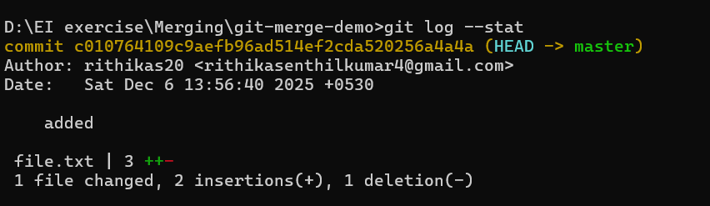
git log –since=” number of days”
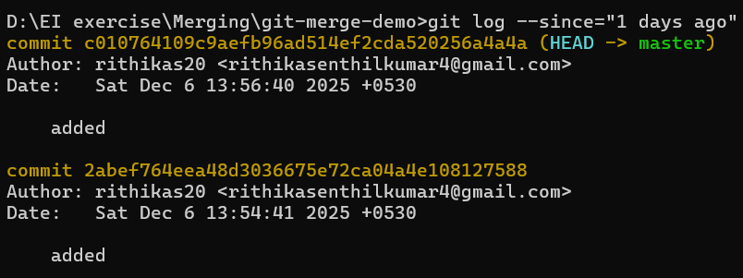
git log –author==”Name”
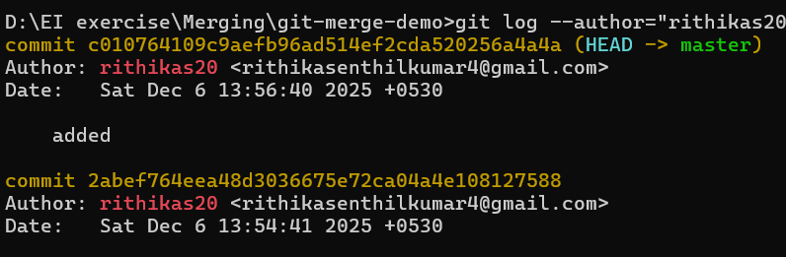
8.) Rename:
git mv <oldname> <newname>
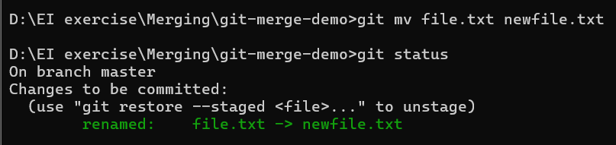
9.)Branch:
git branch <bname>
git checkout <bname>
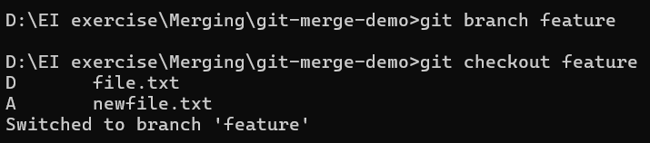

git checkout -b <bname> (Create and move at same time)
git branch (list of all branch)
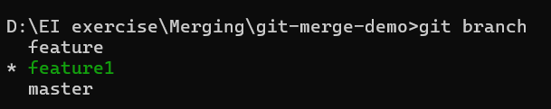
git branch -a (all local + remote)
git branch -r(remote branch)
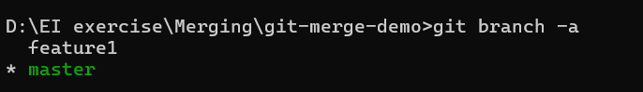
git branch -v (last commit)
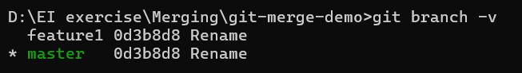
git branch –merged( List the merged branches)
git branch –no-merged( list branches that are not merged yet)
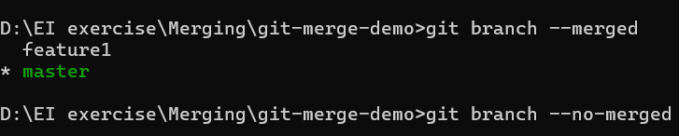
git branch -D <bname> (Force dlt even if not merged)
git remote add < alias_name> <path/url>
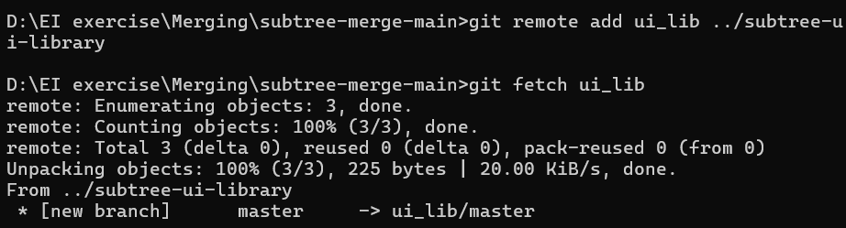
git fetch <alias_name>
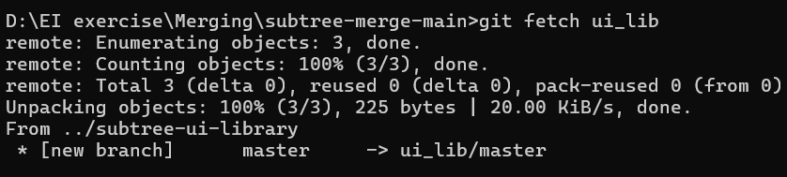
10.)git reflog:
- Even if you lose commits by mistake (reset --hard, rebase rewrite, deleted branch), reflog helps recover them
git reset --hard HEAD~2( lost 2 latest commit)
git reflog
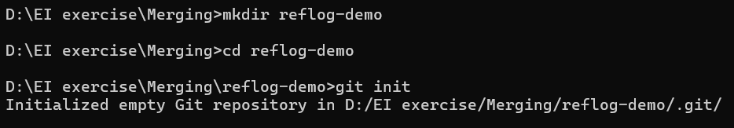
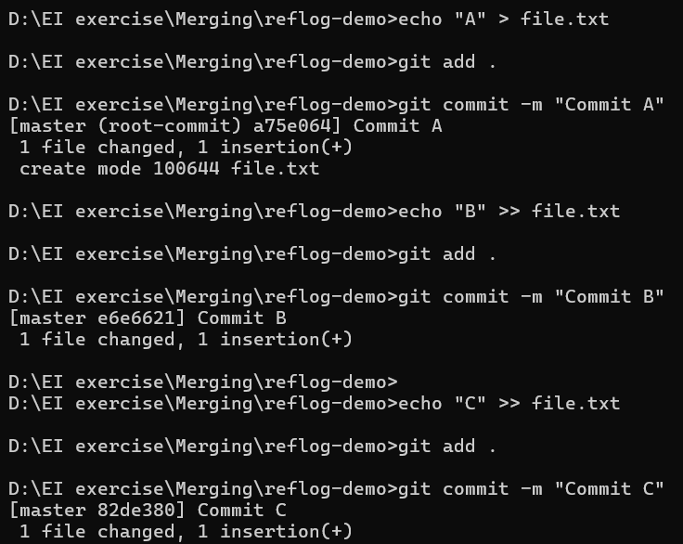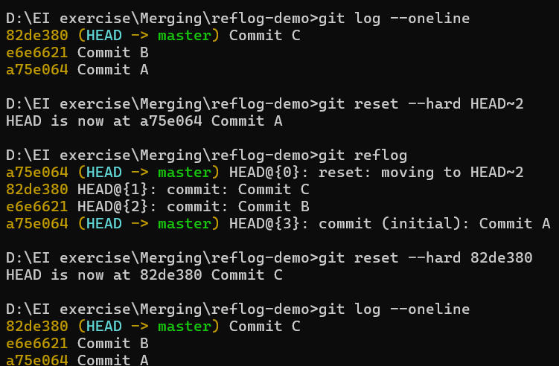

git reflog show main/master - shows the history of where the main branch pointer was previously pointing
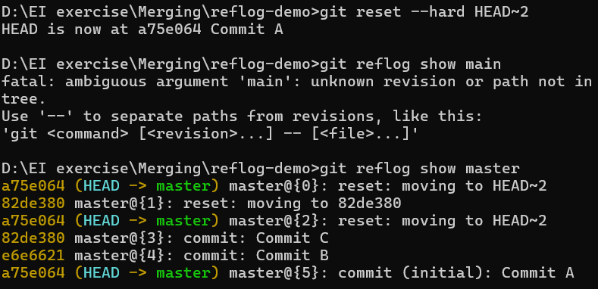
git reflog expire --all --expire=now
git gc --prune=now
